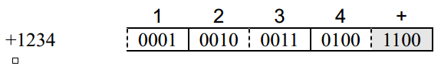

Packed decimal format: **each digit of the decimal number is represented with 4 bits** and the last four bits indicate the sign.

1 byte = 8 bit

In above case, we only need 2,5 bytes to store -1234, but since computers reserve areas in bytes (số bytes là số chẵn, không phải số lẽ, số lẽ là số có dấu phẩy). That’s why, we add 0000 at the beginning. 2,5 bytes => 3 bytes.